

BUILDERS RISK APPLICATION

Name and Address of Applicant: |  |  |  |  | Name and Address of Producer:
Billing Contact Name: |  |  |  |  | Phone Number:
Policy Term: | From: To:
Description of Project/Type of Project:
Location of Project:

Limits of Insurance:
$ |  | At the project site | Deductible | $1,000 | $2,500 |  | $5,000 |  | Other:
$ |  | In temporary storage at any location other than the project site
$ |  | While in transit
$ |  | Extra Expense Limit
$ |  | Loss of Rents Limit
$ |  | Flood Limit | Deductible | $25,000 |  | $50,000
$ |  | Earthquake Limit | Deductible | $25,000 |  | $50,000

Contractor Information:
Name and Address of Contractor: |  | Website Address:

Has contractor engaged in this type of project before? Yes No
If “Yes”, for how many years?

Construction Information:
Fire Resistive / Modified Fire Resistive Non Combustible Frame
Masonry Non Combustible Joisted Masonry

Total Square Feet: Number of Floors Above Ground: Below Ground:

Type of Project: ◻ Ground-Up Construction Renovation/Rehabilitation – (need to complete supplemental application)
Is construction lift slab, tilt up or prototype? Yes No
Is project on filled land? Yes No
If “Yes”, are pilings used? Yes No
Will the project site be: Fenced? Yes No Locked? Yes No
Lighted? Yes No
Will the watchman be on premises during non-working hours? Yes No

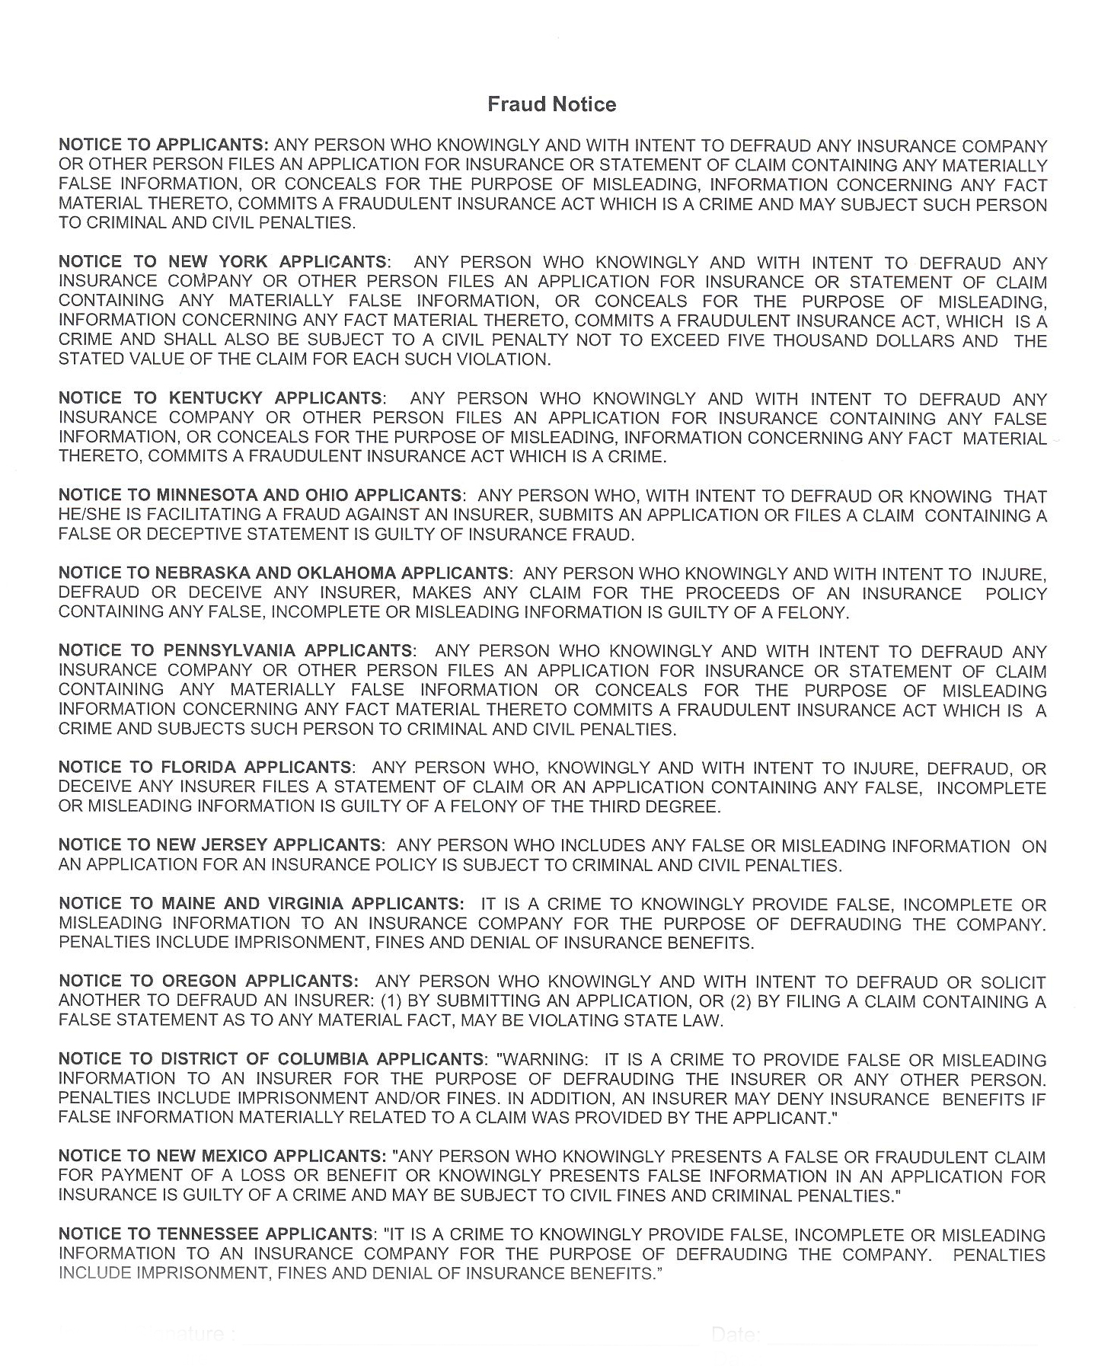
Insured Signature: __________________________________________ Date:
Agent Signature: ___________________________________________ Date:

Pacific Excess Insurance Marketing – 6363 Katella Ave., Cypress, CA 90630
Email Completed Application to: Submissions@PacificExcess.com
Or Fax Application to 714-228-7838

